**Code Explanation for Displaying an image using OpenCV**

**1. Import Required Libraries**

import matplotlib.pyplot as plt

import cv2

**2. Read Image Using OpenCV**

image = cv2.imread('C:/Users/asus/Desktop/Tuwaiq Academy/Dr. Afshan/horse.jpg’)

//Loads the image from the given path.

**3. Error Handling for Image Load**

if image is None: print("Error: Could not load image.")

//Checks if the image was loaded successfully.

**4. Convert Image from BGR to RGB**

image_rgb = cv2.cvtColor(image, cv2.COLOR_BGR2RGB)

//Converts the image color format from BGR (used by OpenCV) to RGB (used by Matplotlib).

**5. Display Image using Matplotlib**

plt.imshow(image_rgb) plt.axis('off') # Removes axes for cleaner view plt.show()

//Displays the image without axes.

**Output**

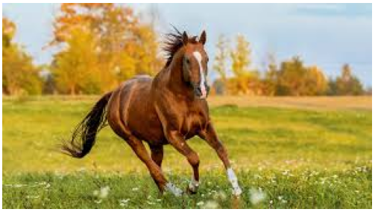

1. **Importing Libraries:**

matplotlib.pyplot (as plt) is used for plotting and displaying the image.

cv2 (OpenCV) is used for reading and processing the image.

1. **Reading the Image:**

image = cv2.imread('C:/Users/asus/Desktop/Tuwaiq Academy/Dr. Afshan/horse.jpg') loads the image from the specified path.

If the image cannot be loaded (e.g., due to an incorrect path or missing file), an error message is printed: print("Error: Could not load image.")

1. **Converting Color Format:**

Images loaded using OpenCV are in BGR format (Blue, Green, Red). Since **Matplotlib** expects RGB (Red, Green, Blue) format for displaying colors correctly, the code converts the image using:

image_rgb = cv2.cvtColor(image, cv2.COLOR_BGR2RGB)

1. **Displaying the Image:**

plt.imshow(image_rgb) displays the image in a Matplotlib window.

plt.axis('off') removes the axes from the image display (so only the image itself is shown).

plt.show() displays the image.